Prosthetic Hand- Meeting Minutes 7 July 2026
Objective:

Minutes from Lily
- Not individual digits
- Will the opposable movement of the thumb that is needed to grip something like a bottle actually tension the wire enough to close the fingers (for the thumb cable pulley mechanism)
- Lego hand option: attach cupped hand shape to wrist with palm of hand as support
- Develop like a claw clip hinge mechanism, torsion spring that would be forced open using the object and the other hand, two parts (on hand as well)
- Problem: will reintroduce using both hands (as one hand has to force it open)
- Option: two points of control- shoulder so the prosthetic curves for larger objects, and wrist to curve the hand for smaller objects
- One big claw with ‘knuckles’ like the thumb cable pulley mechanism
- Part on wrist and connection on shoulder/near elbow
- Shaft that the cable stretches through so the cable isn’t in the way
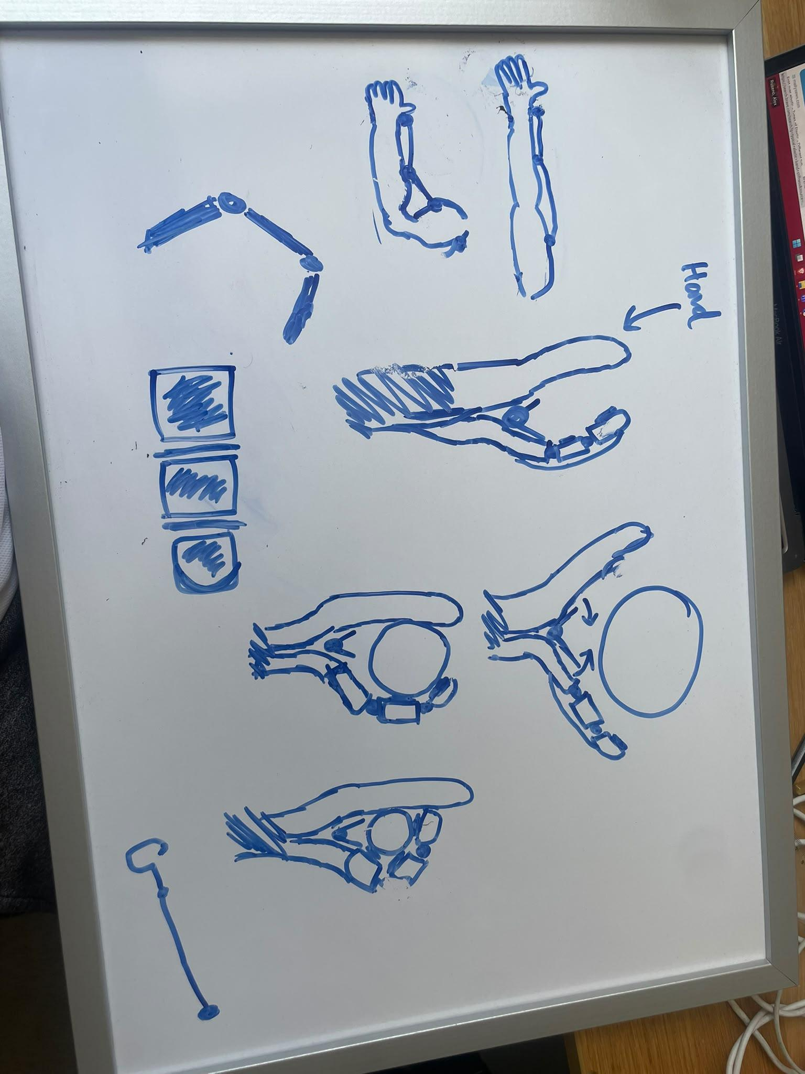
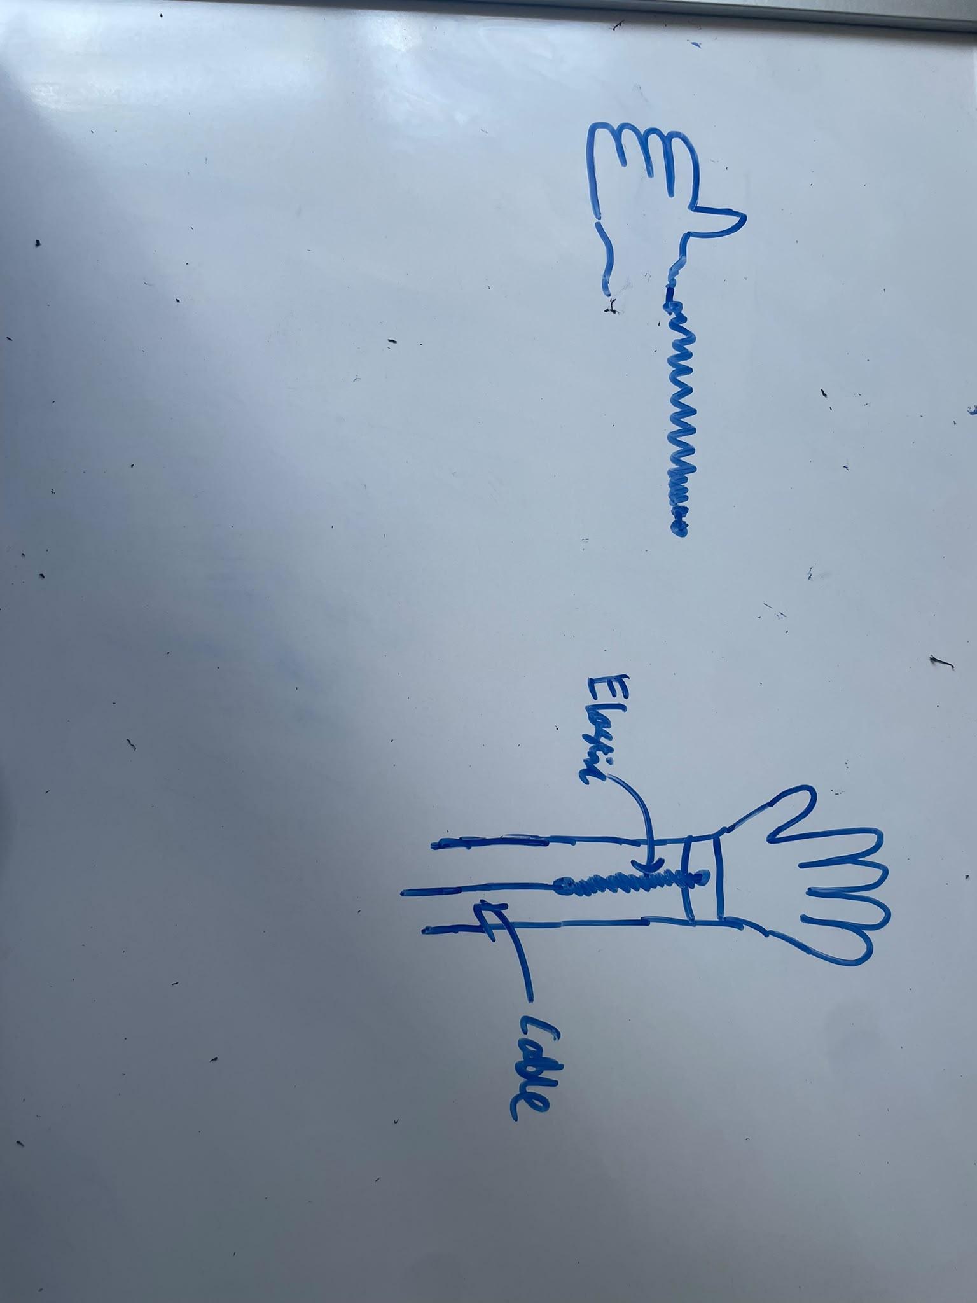

To Do

Procurement:

